**MongoDB**

**Learn some prerequisite to understand MongoDB**

* Initially learn about BSON File.
* Mongo DB doesn't need to pass all values in schema as in MYSql
* It follows storing of value in dictionary pattern that is key: value.
* 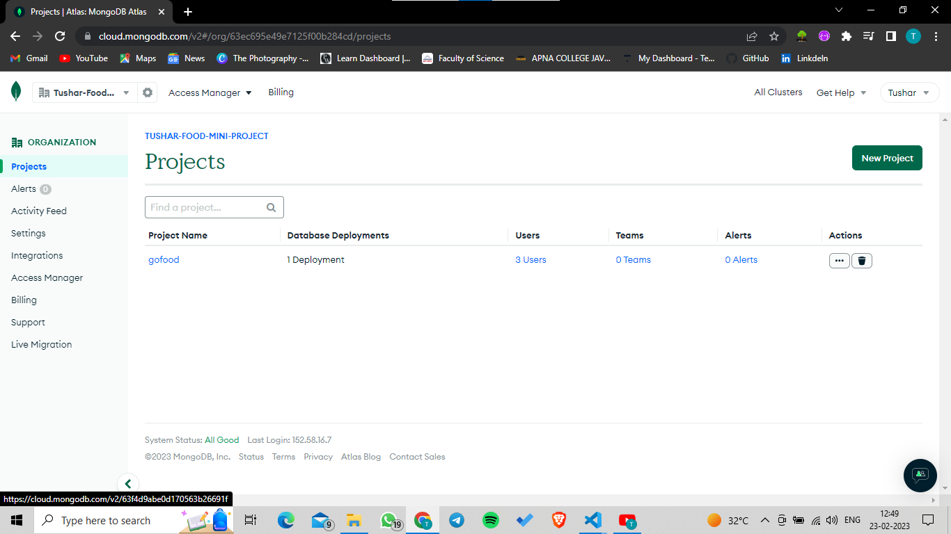

**Import command for fetching json file details in MongoDB Collection**

* mongoimport --uri mongodb+srv://gofood:<PASSWORD>@cluster0.axyrq69.mongodb.net/<DATABASE> --collection <COLLECTION> --type <FILETYPE> --file <FILENAME>
* Graphical user interface, text, application, email

  Description automatically generated

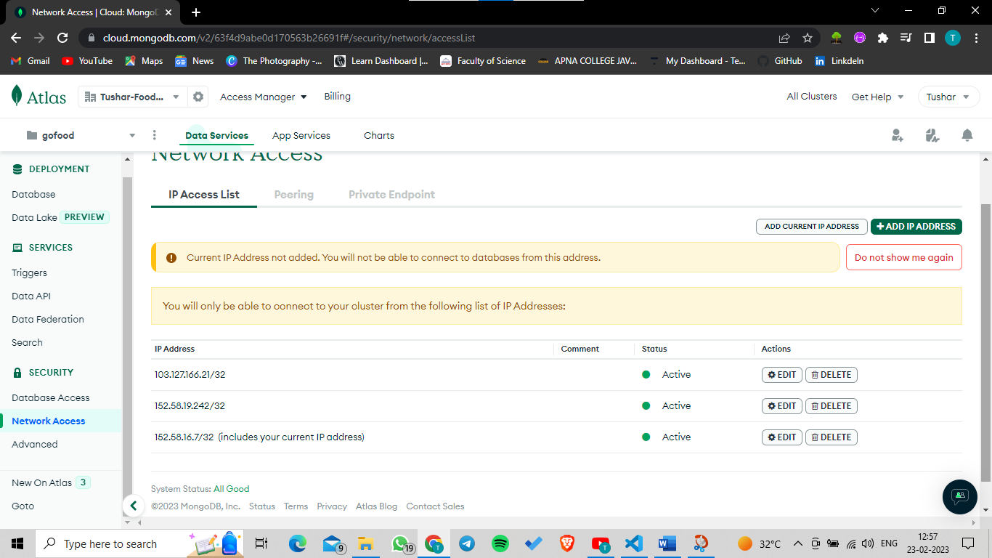

To authenticate purpose we have given IP address of PC so they can only access